 

Middle Tennessee Chapter, Spring 2020

**April 13th Monthly Meeting Cancelled! No Meeting!!!**

**COVID-19 has taken over everything from our regular daily life to our economy. Consequently, the spring newsletter will focus on COVID-19 pandemic and its effect on Safety in the work place. At no other time in the recent history of the United States has a public health issue forced such a change to business operations and daily life. Safety professionals are at the forefront of protecting their workers in the pandemic environment. A summary of the CDC and OSHA Guidelines are included below. Remember the information below is a summary only. Both agencies provide detailed guidance, and we at ASSP encourage you to read the recommendations in full. Links are provided for each organization.**

**CDC Guidance for COVID-19 (*https://www.cdc.gov/coronavirus/2019-ncov/downloads/community-mitigation-strategy.pdf)***

The Centers for Disease Control and Prevention has released guidance for Mitigation Strategies for the spread of COVID-19 in the work place. Mitigation strategies are much like the general population guidelines, but each strategy gains more importance both in the control of the spread of COVID-19 as well as the maintaining of a healthy and safe work place. Specific strategies include the following.

* **Tele-Work**-working from home electronically helps in improving social distancing as well keeps portions of the economy going, safely
* **Social Distancing**-keeping at least 6 feet between workers as well as keeping workers from sharing work spaces and work tools, helps mitigate exposure
* **Staggering Work Schedules**-allowing employees to work a modified shift can limit the number of employees in a given area and further help with social distancing, thus lessening the exposure threat for any working employee
* **Limiting Social Contacts at Work**-keeping social distancing at breaks, and lessening group meetings face to face
* **Decreasing Large Meetings**-using electronic platforms as opposed to have large face to face meetings, and limiting outside visitors each helps to limit large meetings
* **Regular Health Checks**-using screening questionnaires daily and having policies in place in how to isolate and handle exposures will help with transmission occurrences

**OSHA Guidance for COVID-19** ***(https://www.osha.gov/Publications/OSHA3990.pdf*)**

The Occupational Safety and Health Administration has released employer guidance during the COVID-19 pandemic.

OSHA lists basic prevention techniques such as hand washing, social distancing, and sanitization processes. Additionally, OSHA has listed control measures that will be helpful in supporting the United States’ efforts in flattening the curve. Control measures include the following.

**Administrative**

* Personal Protective Equipment (PPE)-masks and gloves can be helpful when in contact with work surfaces or fellow employees
* Requiring Regular Hygiene-cleaning of work surfaces with CDC compliant cleansers between worker’s use, or when away from the work station for a period of time as well as washing hands regularly
* Remote Work/Flexible Work Schedules/Virtual Meetings
* Employee Screenings
* Employee Education-hand washing, use of PPE, company policies and reporting guidelines, methods of sanitizing work spaces

**Engineering**

* Physical Barriers-erecting plastic guards or sneeze guards
* Installing Drive Through- to serve customers without increasing employee exposure

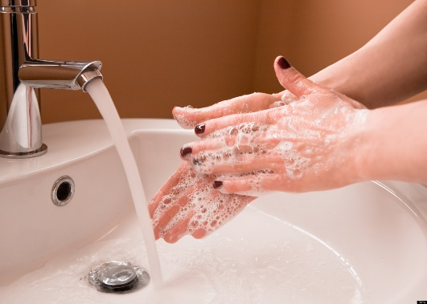

**The summary for all those measures? If we do it as individuals, it is easier to enforce with our employee groups. Check your health regularly-temperature, coughing, sneezing. Take public distancing guidelines seriously in your home and work spaces. Get tested if you have symptoms. Sanitize your work areas and living spaces regularly. And, do what your Momma taught you…Wash Your Hands!!!**

**Upcoming Meetings**

**April 13th Cancelled! No Meeting!!!**

May 11th Annual Golf Outing-This meeting is still possible



Please mark your calendars and plan to register a team for the annual golf outing at Pebble Brook Golf Course on May 11, 2020.  More information to come.